Strayer University

**BUSINESS REQUIREMENTS**

Week 4

**Business Requirements**

for the

Course of

Information Technology Capstone

10/29/18

By

Kennedy Kabaso.

Professor: Barrett Christopher

**Project Deliverable 2: Business Requirements**

**Section 2: Revised Gantt Chart / Project Plan**

Use Microsoft Project or an open source alternative, such as Open Project, to:

2. Update the Gantt chart or project plan (summary and detail) template, from Project Deliverable 1: Project Plan Inception, with all the project tasks.

The specific course learning outcomes associated with this assignment are:

* Apply integrative information technology solutions with project management tools to solve business problems.
* Use technology and information resources to research issues in information technology.
* Write clearly and concisely about strategic issues and practices in the information technology domain using proper writing mechanics and technical style conventions.

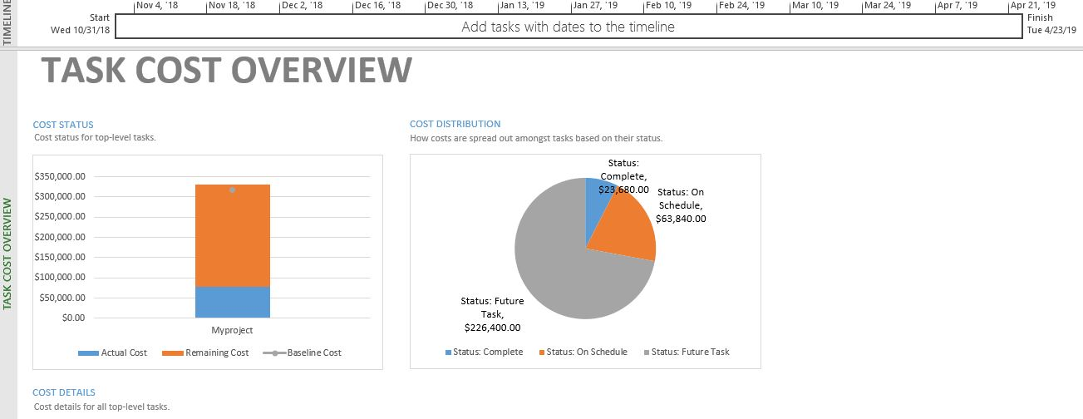

**Gantt Report for our Company**

.